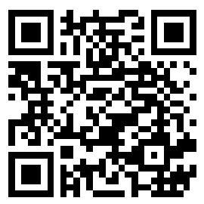

**Launch Events**

***Event Venue***

**ADRESS, ADRESS, PR nnnnn**

**Saturday, Jan 13, 2018 09:00-11:00 AM**

Hindu Swayamsevak Sangh (HSS), San Antonio

**Download SNY App**

**Jan 13 - Jan 28, 2018**

For more detail, please contact:

**Hindu Swayamsevak Sangh**

xxxxxxx@GMAIL.COM /nnn–nnn-nnnn/ nnn-nnn-nnnn

**Health for Humanity Yogathon**

**(Surya Namaskar Yajna)**