Step by Step instructions how to “Track Surya Namaskar Count”

Only co-ordinators need to login. Individual participants need not login

- Have each individual/family fill up the recording sheet and send it to you every week.
- Enter all the information from your Swayamsevaks/Sevikas on the “Coordinators Participant tracking/totalling sheet ()”.
- Just enter the name and individual numbers, totals will be automatically calculated.

- Every week latest by Tuesday 4:00 PM go to the web site http://www.hssus.org/sny under resources click on “SNY login”.
- Click on “logged in” to login when you see you must be logged in to use this page.
- Please enter your e-mail id as “username” and also as “password”. They are case sensitive.

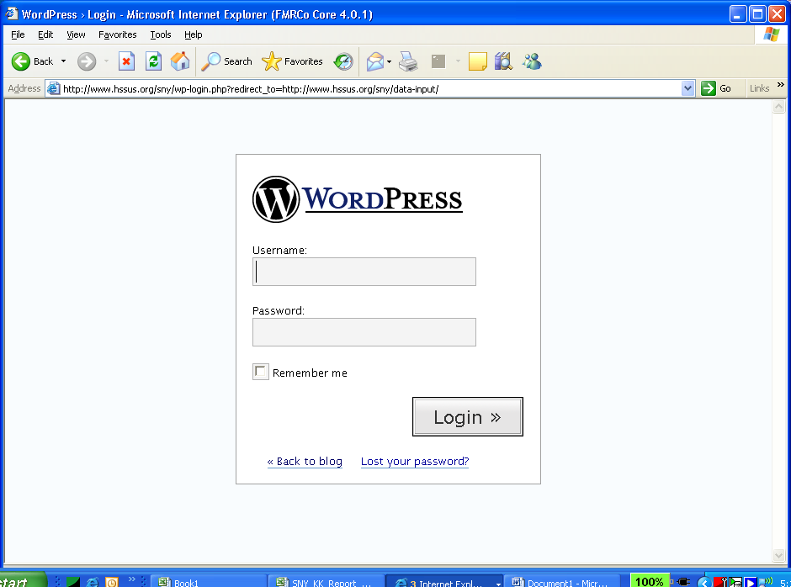

- Select your shakha’s name (only your Shakha will show up. Sambahg coordinators will be able to see all Shakhas)

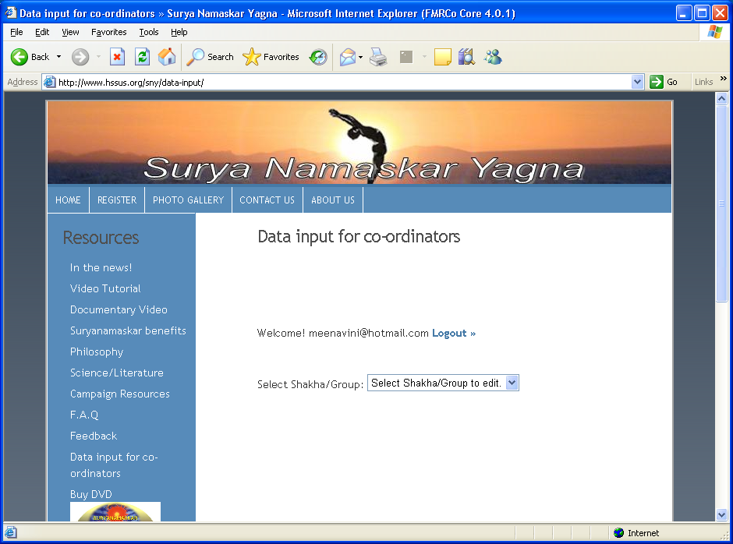

- Enter the data from spreadsheet into the form

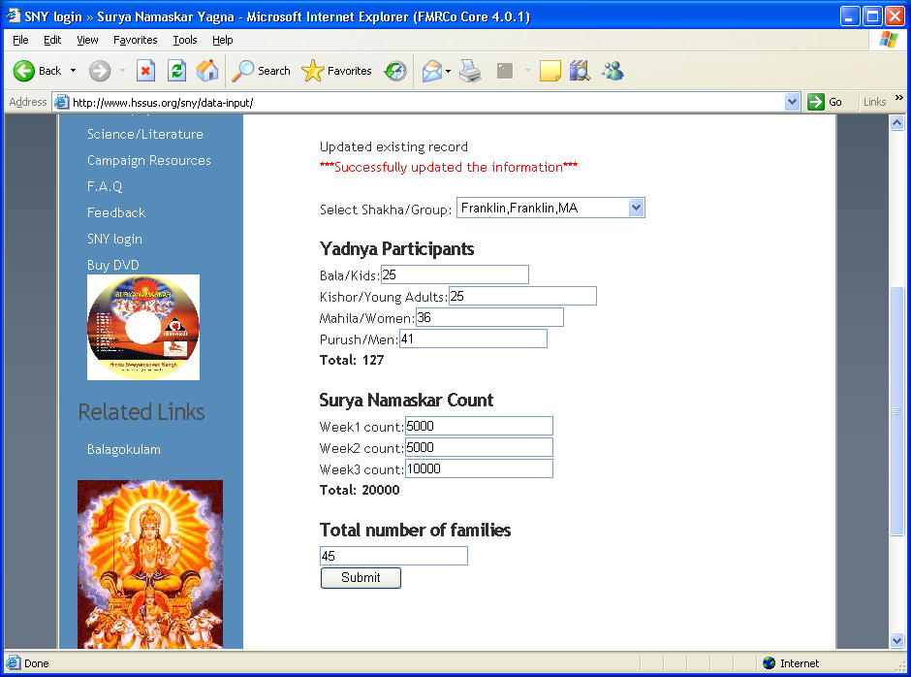

- Please do not leave any data blank. If you do not have any information, enter “0” (zero). If you leave it, it will default to zero.

- Once you enter all the data press the Submit button.

- Logout by pressing the Logout button

- If you need to correct the data, please feel free to change the data in any row and press the submit button
(Ex: week 1 count you entered 200, you want change it to 300, go ahead change it)

- Please note that number of family participating will be determined by each Shaka KKs.

- Please also note we track total number of people participated in the yagna during the 16 days period. Not necessary all of them should have participated on all 16 days).
Few examples 1st week 20 Bala’s participated, 2nd week 5 dropped out from that list and 3rd week 3 new bala’s participated, you will enter
1st week Bala/Kids 25
2nd week Bala/Kids 25 (no changes)
3rd week Bala/Kids 28 (you will add 3 new balas).

If you are experiencing login issues please try couple of things here
These are the items that I have noticed while working on my login and some other logins.

- Make sure that the case matches, most of the login names are lowercase, however some were upper case. To get an exact list, visit http://www.hssus.org/sny/sny_files/ShakhaSNYcoordinators.pdf and check the exact typing of your email alias.
- Make sure that there is no blank space at the end of the username or password. If you copy-paste from the emails, then it might actually append a blank space at the end of your user name (and password)
- You should enable cookies on your browser. Internet Explorer will typically show an eye-like icon with a red-cross mark on it indicating that a cookie was blocked. You should not see this icon when you access http://www.hssus.org
- Add http://www.hssus.org to your list of Trusted Sites. To do this in Internet Explorer, Navigate as follows - Tools menu - Internet Options -> Security -> Click on Trusted Sites -> Click Sites button -> Unselect "Require Server Verification (https) " check box -> Under "Add this website to the zone" type http://www.hssus.org and click Add. Click Close, Click Apply. Restart Internet Explorer and then try to login.
- If you have ZoneAlarm or any such firewall, ensure that www.hssus.org has been granted permissions for Mobile Code and Private Headers

