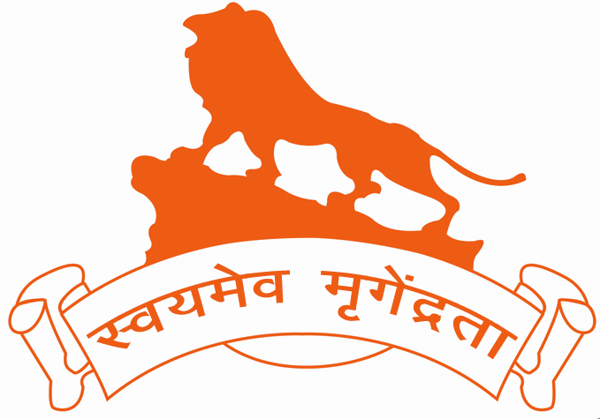


Hindu Swayamsevak Sangh (USA)

Invites everyone to participate in


Surya Namaskar Yajna
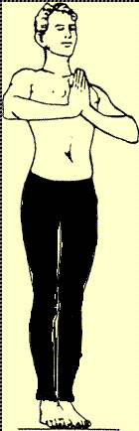
(Sun Salutation to manifest the Divinity within)

Date: Jan 11th to Jan 26th, 2014

- Introduce and practice Yoga in our daily life
- Simple asanas for physical and intellectual development
- Lead a healthy lifestyle with eternal bliss

To participate in the yajna:

- Visit Shakha/Balagokulam near you or http://www.hssus.org/sny
- Learn how to do Surya Namaskar
- Do Surya Namaskar at home everyday and keep count
- Give the total count to your Shakha/Balagokulam coordinator

    - Participating kids will receive a certificate

Contact Address:

Email: sny@hssus.org

http://www.hssus.org/sny



Surya Namaskar Positions
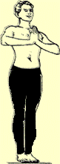






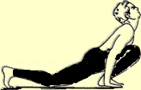
 Mitrāya Namah
 Ravaye Namah
 Suryāya Namah
 Bhānave Namah
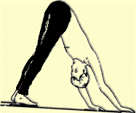
( Khagāya Namah
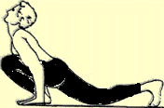
( Pushne Namah
( Hiranyagharbhāya Namah
( Marichaya Namah
( Ādityāya Namah
( Sāvitre Namah

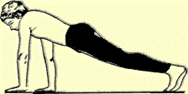

 Ārkāya Namah
 Bhāskarāya Namah
 Srisavitrusuryanārāyanāya Namah



